TC-REF-003
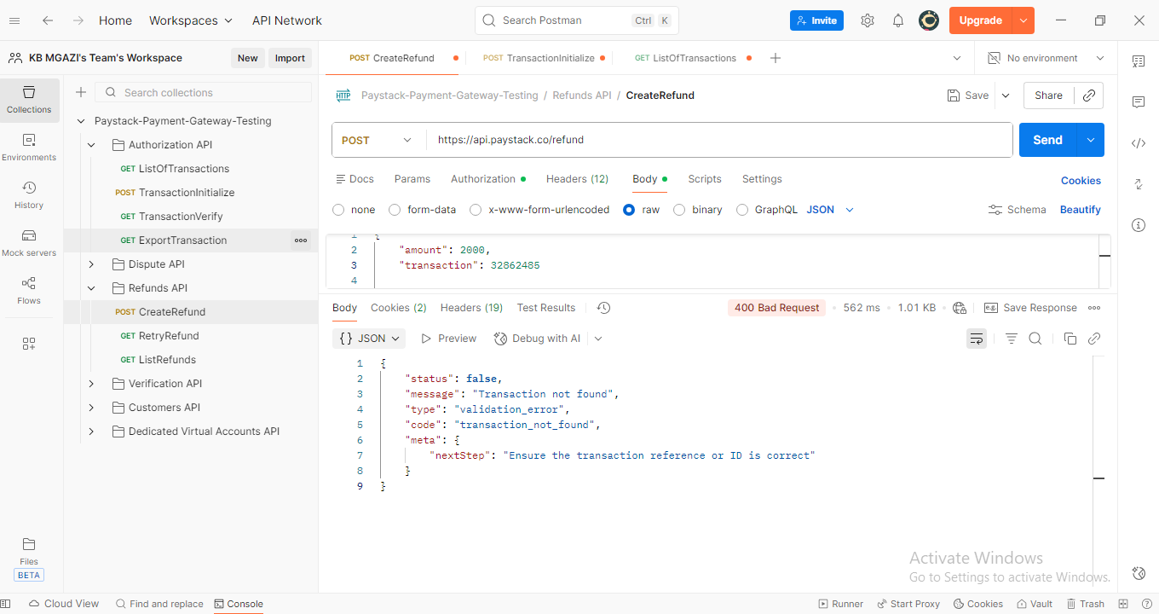
Request:
{
"amount": 2000,
"transaction": 32862485

}

Response:
{
"status": false,
"message": "Transaction not found",
"type": "validation_error",
"code": "transaction_not_found",
"meta": {
"nextStep": "Ensure the transaction reference or ID is correct"
}
}

